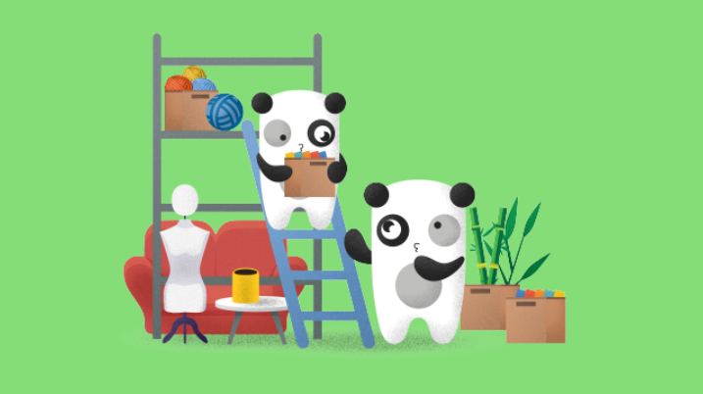
Bored Panda Studios is among the biggest YouTube and Facebook video producers and publishers globally and owns one of the main DIY channels (Crafty Panda) on YouTube with more than 18M subscribers around the world. Bored Panda Studios has the biggest TikTok account in Lithuania, 300M monthly video views on YouTube, and over 2 billion on Facebook. And we are growing every day! This time, we are looking for a proactive, ambitious, and hard-working Intern in Art Department to join our team for at least two months or even more in our office in Vilnius. We are offering full-time or part-time internships! You can check how we work here!
We offer:
- Wide career opportunities in unlimited internet with our unlimited resources (Bored Panda Studios is growing day by day and with it – endless possibilities).
- To be a part of a great creative team and work in a dynamic atmosphere;
- Ability to understand filming process better and participate in it daily;
- Learn day by day about Youtube and production.
You will:
- Be the helping hands in daily urgent situations on set;
- Help your team to fulfill ideas in filming set according to specific theme or idea;
- Be in charge of maintaining the set tidy and in order;
- Work in close collaboration with set designers team to create the vision for filming set through furniture, decorations, colors and other interior details;
- Assist by coordinating concepts with the props team, cameramen, producers, directors and other.

Requirements (would be a plus):
- Knowledge of the visual arts and production processes;
- Knowledge of interior design and understanding the main color matching rules;
- Knowledge how to work with set constructions as well as assemble and repair furniture;
- Set design experience in film making industry;
- Uphold a positive attitude with the ability to process constructive criticism and accept feedback as a growth opportunity;
- Adobe Photoshop skills;
- Rapidly respond to changing work environment.

If you are interested we are waiting for your application!

Only selected candidates will be contacted.

